UML DIAGRAMS

SMART INTERVIEW PREPARATION PLATFORM

1. Use Case Diagram
The Use Case Diagram defines the high-level functionalities of the Smart Interview Preparation Platform and visualizes how different external entities (Actors) interact with these functionalities. It establishes the system's boundary and primary goals.

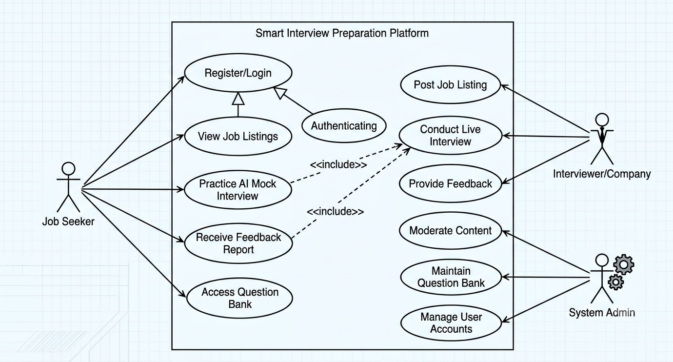

Explanation:
- System Boundary: The blue rectangle represents the 'Smart Interview Preparation Platform' application. Only use cases inside the box are handled by the system.
- Actors:
  - Job Seeker: Interacts with the platform to improve skills and find jobs (e.g., 'Practice AI Mock Interview', 'View Feedback').
  - Interviewer/Company: Uses the platform to find and evaluate candidates (e.g., 'Create Job Listing', 'Provide Feedback' for live interviews).
  - Admin: Manages the overall system operation (e.g., 'Moderate Content', 'Maintain Question Bank').
- Use Cases (Ovals): Specific functions available within the system. Note the relationships: Practice AI Mock Interview includes Access Question Bank (the former cannot function without the latter).

2. Class Diagram
The Class Diagram provides a static structural view of the Smart Interview Preparation Platform. It shows the system's blueprints, detailing the classes, their attributes (data), operations (functions), and the relationships between them. This diagram is derived directly from the entities identified in the conceptual design.
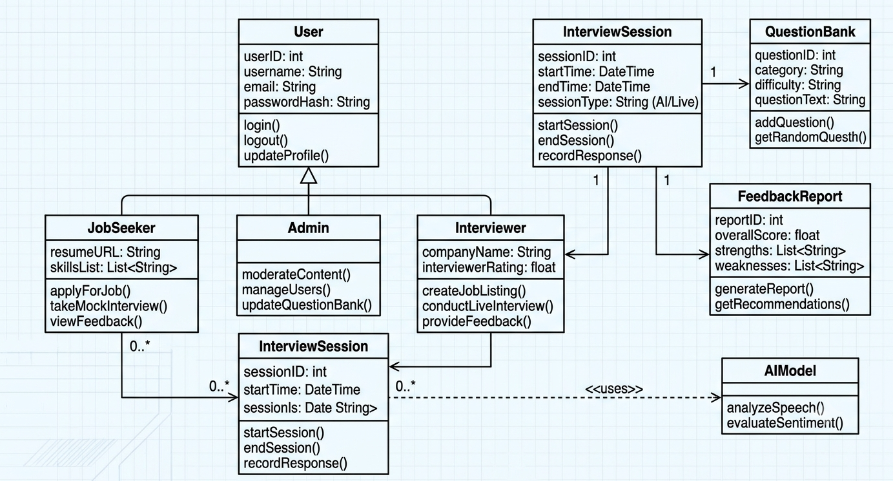

Explanation:
- Classes and Structure: The diagram shows essential classes like User, JobSeeker, Admin, Interviewer, InterviewSession, FeedbackReport, QuestionBank, and AIModel. Each box has compartments for name, attributes, and operations.
- Inheritance (Generalization): JobSeeker, Admin, and Interviewer inherit from the generalized User class (symbolized by the large open arrow), meaning they share common attributes like name and email.
- Associations and Multiplicities:
  - A JobSeeker has zero or many (0..*) InterviewSessions.
  - An InterviewSession always belongs to one (1) JobSeeker and utilizes exactly one (1) AIModel and one QuestionBank.
  - An Interviewer is associated with generating one or many (1..*) FeedbackReports for live interviews.
  - A FeedbackReport relates the JobSeeker, an optional Interviewer, and an InterviewSession.

3. Sequence Diagram
The Sequence Diagram illustrates the dynamic interaction between objects in the system over time. It details how the system components exchange messages to fulfill a specific scenario, in this case: "Job Seeker takes AI Mock Interview".
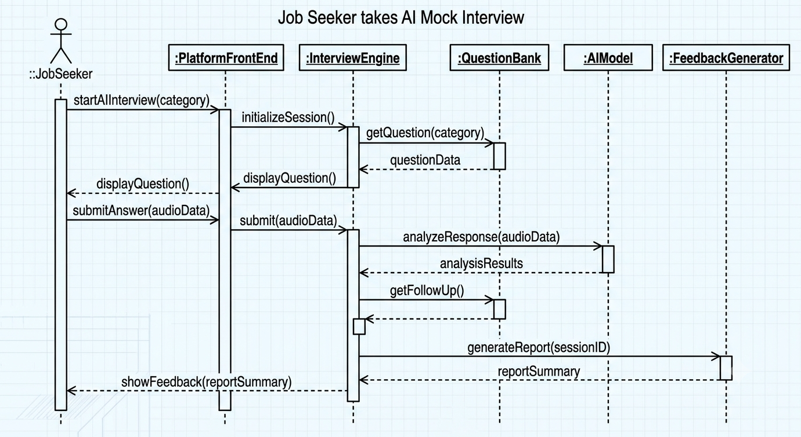

Explanation:
- Lifelines: The vertical dashed lines represent the existence of objects over time (Actor, Front-End, Interview Engine, Question Bank, AI Model, Feedback Service).
- Messages: Horizontal arrows show data exchange.
  - The Job Seeker starts the interview (startInterview).
  - The Platform Front-End initializes the session.
  - The Interview Engine sequentially coordinates getting questions (getQuestion) from the Question Bank, recording the user's answer, and sending it to the AI Model for real-time analysis (analyzeSpeech).
  - After the final question, the engine triggers the Feedback Service to generateReport.
  - Finally, the results are presented back to the Job Seeker via the Front-End.
- The activation boxes (vertical rectangles) indicate when an object is actively processing a request. This diagram shows a complex, multi-component interaction handled seamlessly.

4. Activity Diagram
The Activity Diagram models the dynamic workflow of a major process within the system: "AI-Powered Practice Interview". It emphasizes the flow of control and data from one activity to another, showcasing decision points and parallel processing.
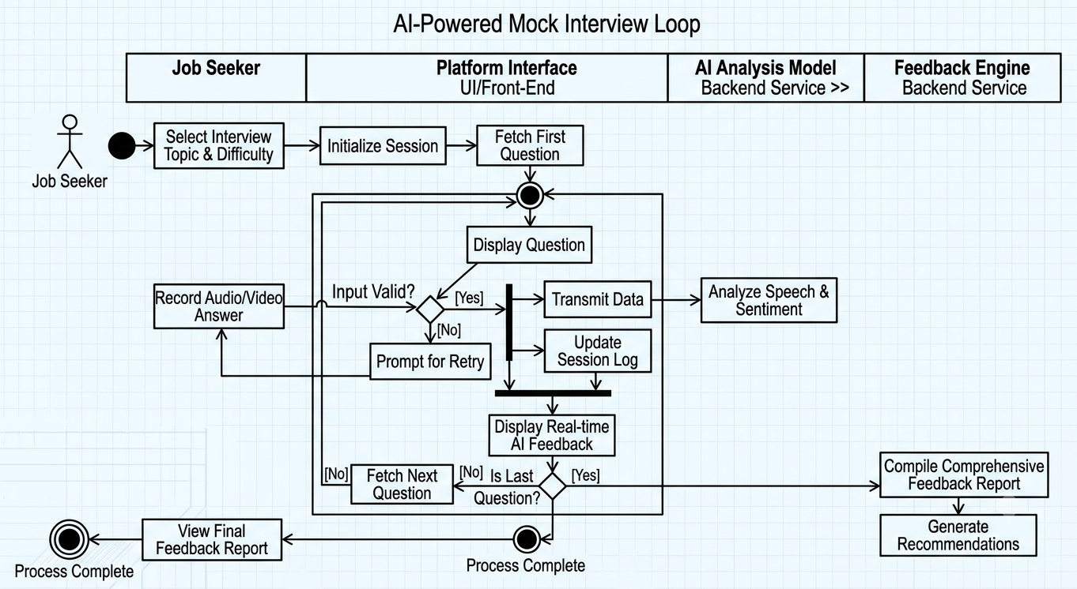

Explanation:
- Swimlanes: The diagram is partitioned into swimlanes (Job Seeker, Platform Interface, AI Model, Feedback Engine) to clarify responsibility for each action.
- Workflow: The process starts (Start Node) with topic selection. An 'Interview Loop' section contains the core interaction: receiving a question, the user recording an answer, and the AI immediately analyzing speech and sentiment.
- Decisions: Decision diamonds split the flow based on conditions (e.g., 'Correct input?', 'Last Question?').
- Parallelism: Synchronization bars (thick horizontal lines) are used to show parallel processing—the Feedback Engine starts analyzing the data while the Job Seeker is viewing immediate feedback during the loop. The process consolidates before displaying the final report (End Node). This diagram visualizes the complex, concurrent nature of the AI interaction
5. State Machine Diagram
The State Machine Diagram illustrates the lifecycle of a key system entity: the InterviewSession object (defined in the Class Diagram). It shows the significant states the object can exist in and the events or conditions that cause it to transition from one state to another.
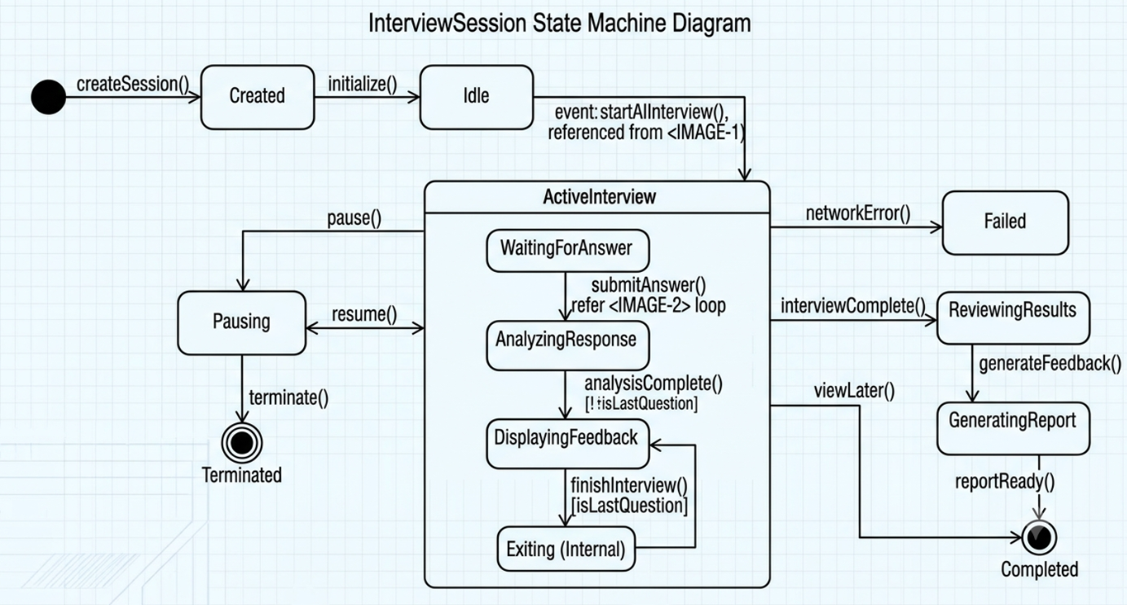

Explanation:
- States (Rounded Rectangles): The session begins in the Created state (Initial State). It moves through various states like Idle, ActiveInterview, Pausing, ReviewingResults, Completed, and Failed.
- Composite State: ActiveInterview is a composite state, indicating it contains substates (as seen in the internal workflow of the Activity Diagram, image_3.png) where the interview loop occurs.
- Transitions (Arrows): Events trigger movement between states. For example, startInterview() moves the session to ActiveInterview. A network error moves the session to Failed.
- Guard Conditions: Text in brackets (e.g., [lastQuestion], [scoreReady]) acts as a guard, meaning the transition only occurs if that specific condition is true. This diagram ensures the system correctly handles interruptions (pause/resume), failures, and normal completion of an interview session.

